NASA Imager for Magnetopause-to-Aurora Global Exploration (IMAGE)

NASA成像仪磁层顶到极光全球勘探（图）

In late 2005, NASA lost one of its satellites called Imager for Magnetopause-to-Aurora Global Exploration (IMAGE).

在2005年底，美国航空航天局失去了它的一个卫星，称为对生物Magnetopause-to-Aurora全球勘查（图）。

IMAGE was launched from Vandenberg AFB on March 25, 2000; its mission was to observe the Earth&rsquo;s magnetosphere, and how it is affected by solar wind. See Figure 1.

图像从范登堡空军基地在2000年3月25日推出；它的任务是观察地球&rsquo；的磁层，以及它是如何由太阳风的影响。见图1。

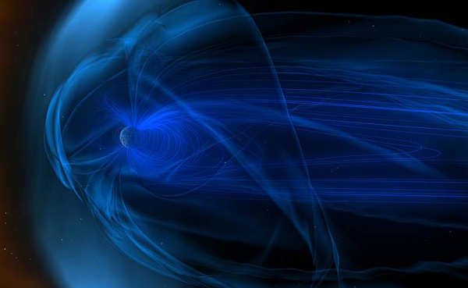

图1: Magnetic fields, known as the magnetosphere, surround Earth. Shown here is an artists conception of the constant stream of particles flowing by from the solar wind. The solar wind speed variations buffet the Earth's magnetic field and produce storms in the Earth's magnetosphere. (Image courtesy of NASA)

图1: 磁场，被称为磁层，环绕着地球。这里显示的是一个艺术家的粒子流从太阳风的恒流的概念。太阳风的速度变化使地球磁场发生变化，并在地球磁层产生风暴。（图片来源于美国宇航局）

The solar wind emanates from the Sun in all directions at speeds of about 400 km/s (about 1 million miles per hour). The source of the solar wind is the Sun's hot corona. The temperature of the corona is so high that the Sun's gravity cannot hold on to it. We do understand why this happens; however, we do not understand the details about how and where the coronal gases are accelerated to these high velocities. See Figure 2

太阳风以400公里/秒（每小时100万英里）的速度从四面八方向太阳发出。太阳风的源头是太阳的炽热日冕。日冕的温度太高，以至于太阳的引力无法控制它。我们确实理解为什么会发生这种情况，但是，我们不了解日冕气体是如何和在何处加速到这些高速度的。参见图2

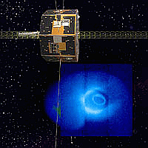

图2: IMAGE and the Solar Wind (Image courtesy of NASA)

图2: 图像和太阳风（美国宇航局提供的图片）

IMAGE utilizes neutral atom, ultraviolet, and radio imaging techniques to study the Solar Wind. A suite of three neutral atom imagers (NAI) provided energy- and composition-resolved images at energies from 10 eV to 200 keV with a time resolution of 300 seconds. Two ultraviolet imagers, covering wavelength ranges from 120-180 nm and provide coverage in the Far UltraViolet (FUV) and 30.4 nm Extreme UltraViolet (EUV). The radio plasma imager (RPI) is a low-power RADAR which operates in the radio frequency bands that contain the plasma resonance frequencies characteristic of the Earth's magnetosphere (3 kHz to 3 MHz).

图像利用中性原子、紫外光和射电成像技术研究太阳风。一套三个中性原子成像仪（NAI）提供能量和成分分辨图像的能量从10电子伏特至200 keV的用300秒的时间分辨率。两个紫外成像仪，覆盖的波长范围从120-180 nm和在远紫外（FUV）提供覆盖30.4 nm的极端紫外线（EUV）。射频等离子体成像仪（RPI）是一种低功耗雷达工作在无线电频段包含等离子体共振频率特性的地球的磁层（3千赫至3兆赫）。

Recently, an amateur astronomer, Scott Tilley in Roberts Creek, British Columbia, amazingly found NASA&rsquo;s IMAGE spacecraft more than 12 years after it went dark.

近日，一位业余天文学家，Scott Tilley罗伯茨溪，不列颠哥伦比亚，令人惊讶的发现，美国宇航局&rsquo；的图像的航天器12多年后，它走到天黑。

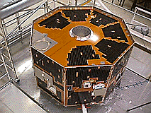

图3: The IMAGE spacecraft at NASA being constructed and tested prior to year 2000 launch (Image courtesy of NASA)

图3: NASA的图像飞船在2000年发射前建造和测试（图片由NASA提供）

As of Thursday, February 1, 2018 the first data files, indicating the state of the spacecraft, have been successfully decoded. NASA&rsquo;s IMAGE team found that the spacecraft&rsquo;s battery is fully charged at 100%, and its temperature is in line with those in 2005 when it was lost.

截至星期四，2018年2月1日，第一个数据文件，表明航天器的状态，已成功解码。美国宇航局的图像研究小组发现，太空船的电池完全充电为100%，其温度与2005时的温度是一致的。

Engineers at The Johns Hopkins University Applied Physics Lab (APL) continue to capture IMAGE data. The spacecraft has two sets of redundant hardware: Primary side A and backup side B. Scientists have determined that they are now running again on Side A of the Power Distribution Unit (PDU) &ndash; a surprise since it had been thought that the side A was dead after a presumed power failure on Thanksgiving Day in 2004 when it switched to its backup Side B hardware.

约翰霍普金斯大学应用物理实验室（APL）的工程师继续捕捉图像数据。飞船有两套冗余的硬件：一次侧和备份方面科学家们已经确定，他们现在又在配电单元（PDU）侧运行& ndash；因为它已经认为，假定断电感恩节在2004时切换到备份硬件后，乙方旁边的一个死了一个惊喜。

The ultimate cause of the current reboot is still not known, but NASA findings suggest that a reboot in some form has in fact, occurred.

目前重新启动的最终原因尚不清楚，但美国宇航局的研究结果表明，某种形式的重新启动实际上已经发生。

The data indicate an overall healthy spacecraft. The next steps for the IMAGE team are to see if they can do more than just listen to the spacecraft, and talk back to it. NASA team efforts are still underway. More on this effort coming soon on Planet Analog regarding the IMAGE on board imagers like the Radio Plasma Imager (RPI), the Medium Energy Neutral Atom (MENA) imager, and the Low Energy Neutral Atom (LENA)

这些数据表明一个健康的宇宙飞船。图像小组的下一步是看他们是否能做更多的事情，而不是仅仅听飞船，然后再对它说话。美国国家航空航天局的团队工作仍在进行中。更多关于这方面的努力即将在行星的模拟对于板成像像无线电等离子成像图像（RPI），中等能量的中性原子成像仪（曼娜），和低能量的中性原子（莱娜）

Also see

也看到了

How NASA helps Earth in natural disasters

美国航空航天局如何帮助地球应对自然灾害

NASA TDRS-M communications satellite

美国宇航局tdrs-m通信卫星